Page 1 — Create an Amazon S3 Bucket
Topic: Bucket creation and initial S3 security settings
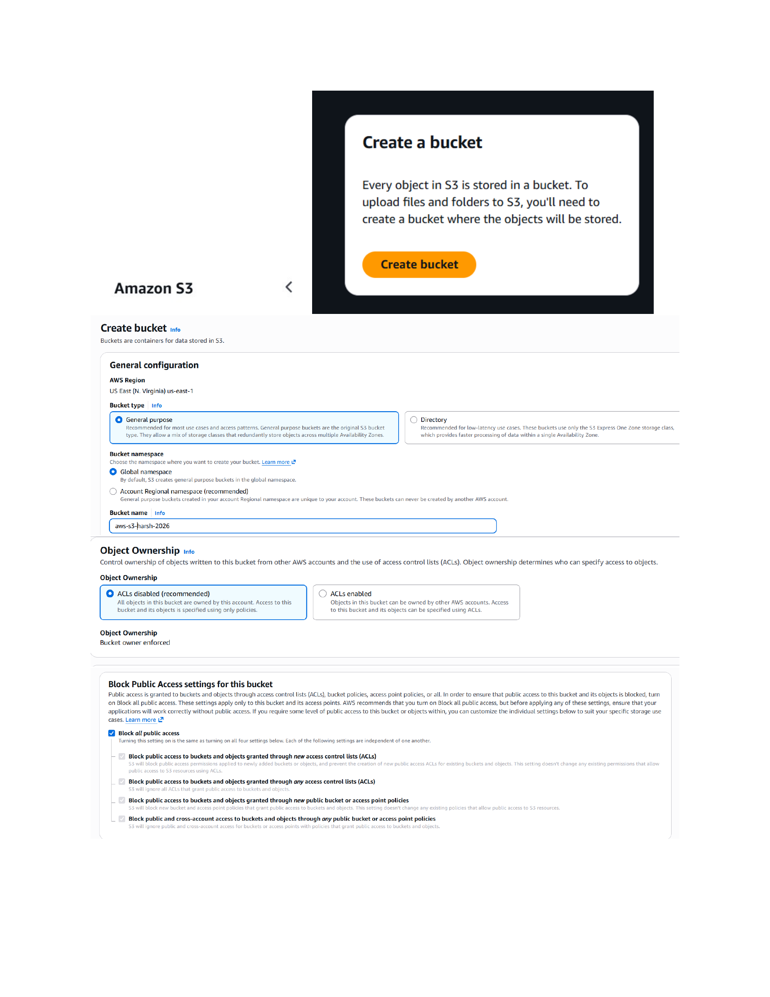
Actual action: The S3 Create bucket page is configured for the shown bucket name, General purpose bucket type, ACLs disabled/Object Ownership setting, and Block Public Access settings.

Page 2 — Open the S3 Bucket
Topic: Bucket overview and object management
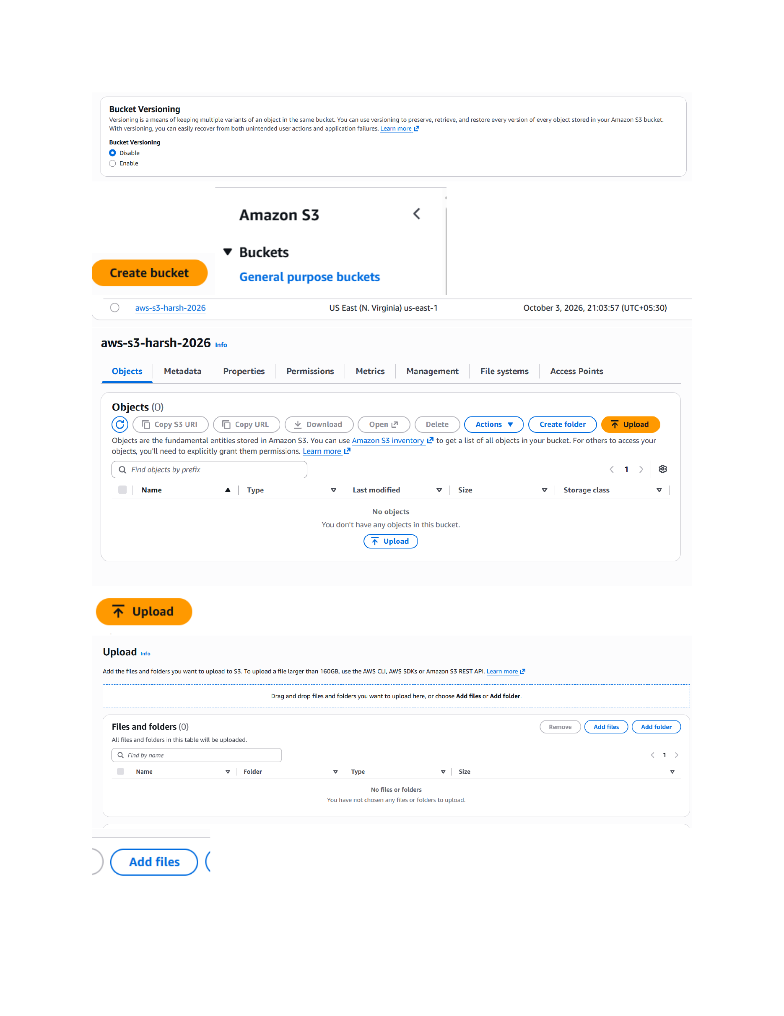
Actual action: The newly created S3 bucket is opened in Amazon S3 and the bucket contents/object-management area is displayed.

Page 3 — Upload an Object to S3
Topic: Uploading files into the bucket
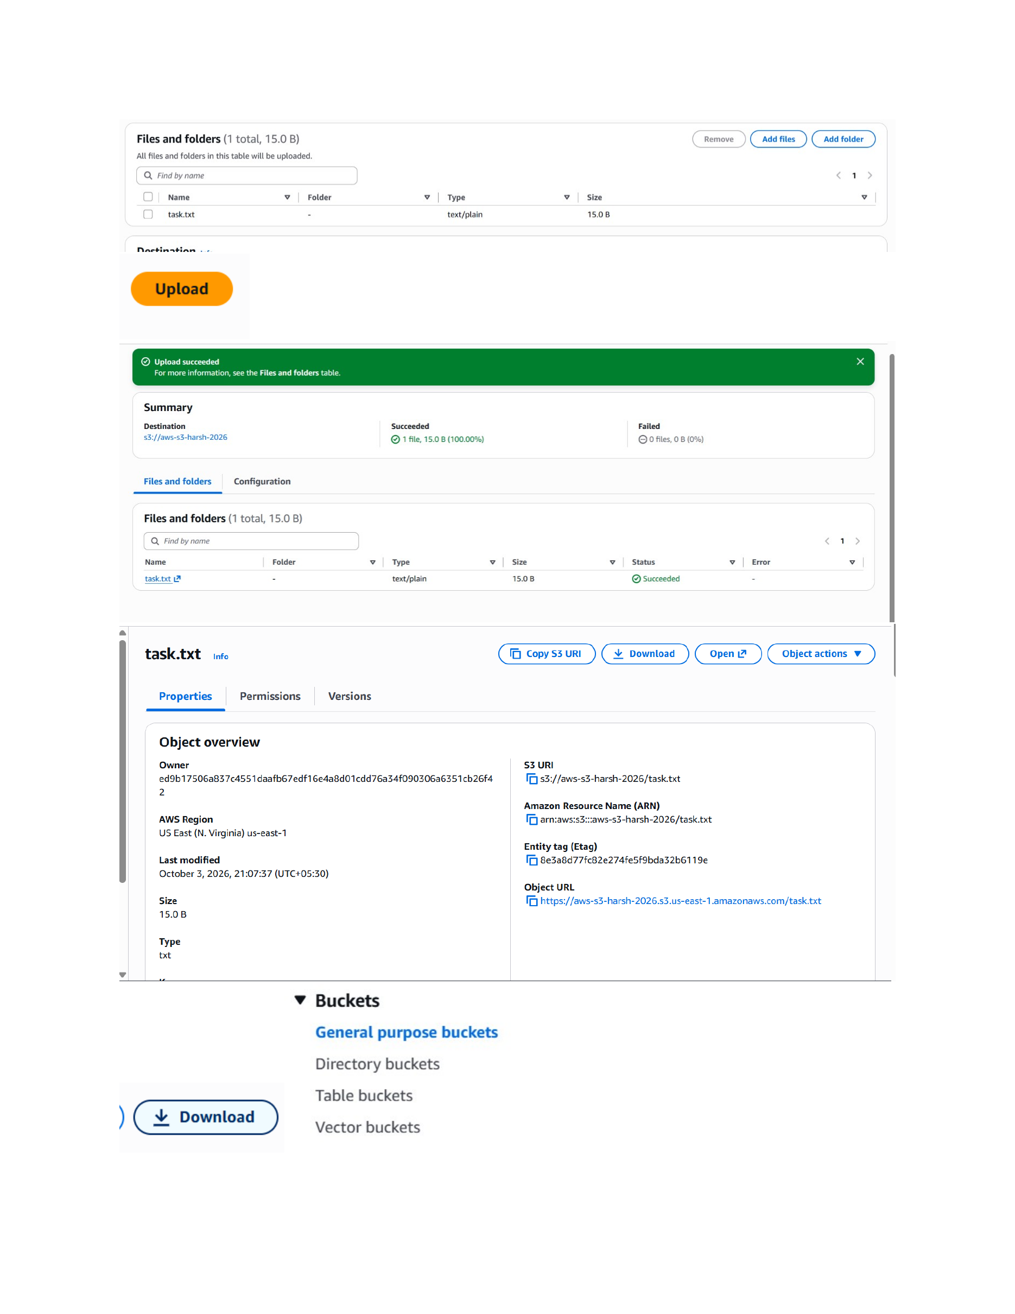
Actual action: The S3 Upload workflow is used to select and upload an object into the bucket, with the upload result shown on the bucket page.

Page 4 — Create a Folder in the Bucket
Topic: S3 folder/object organization
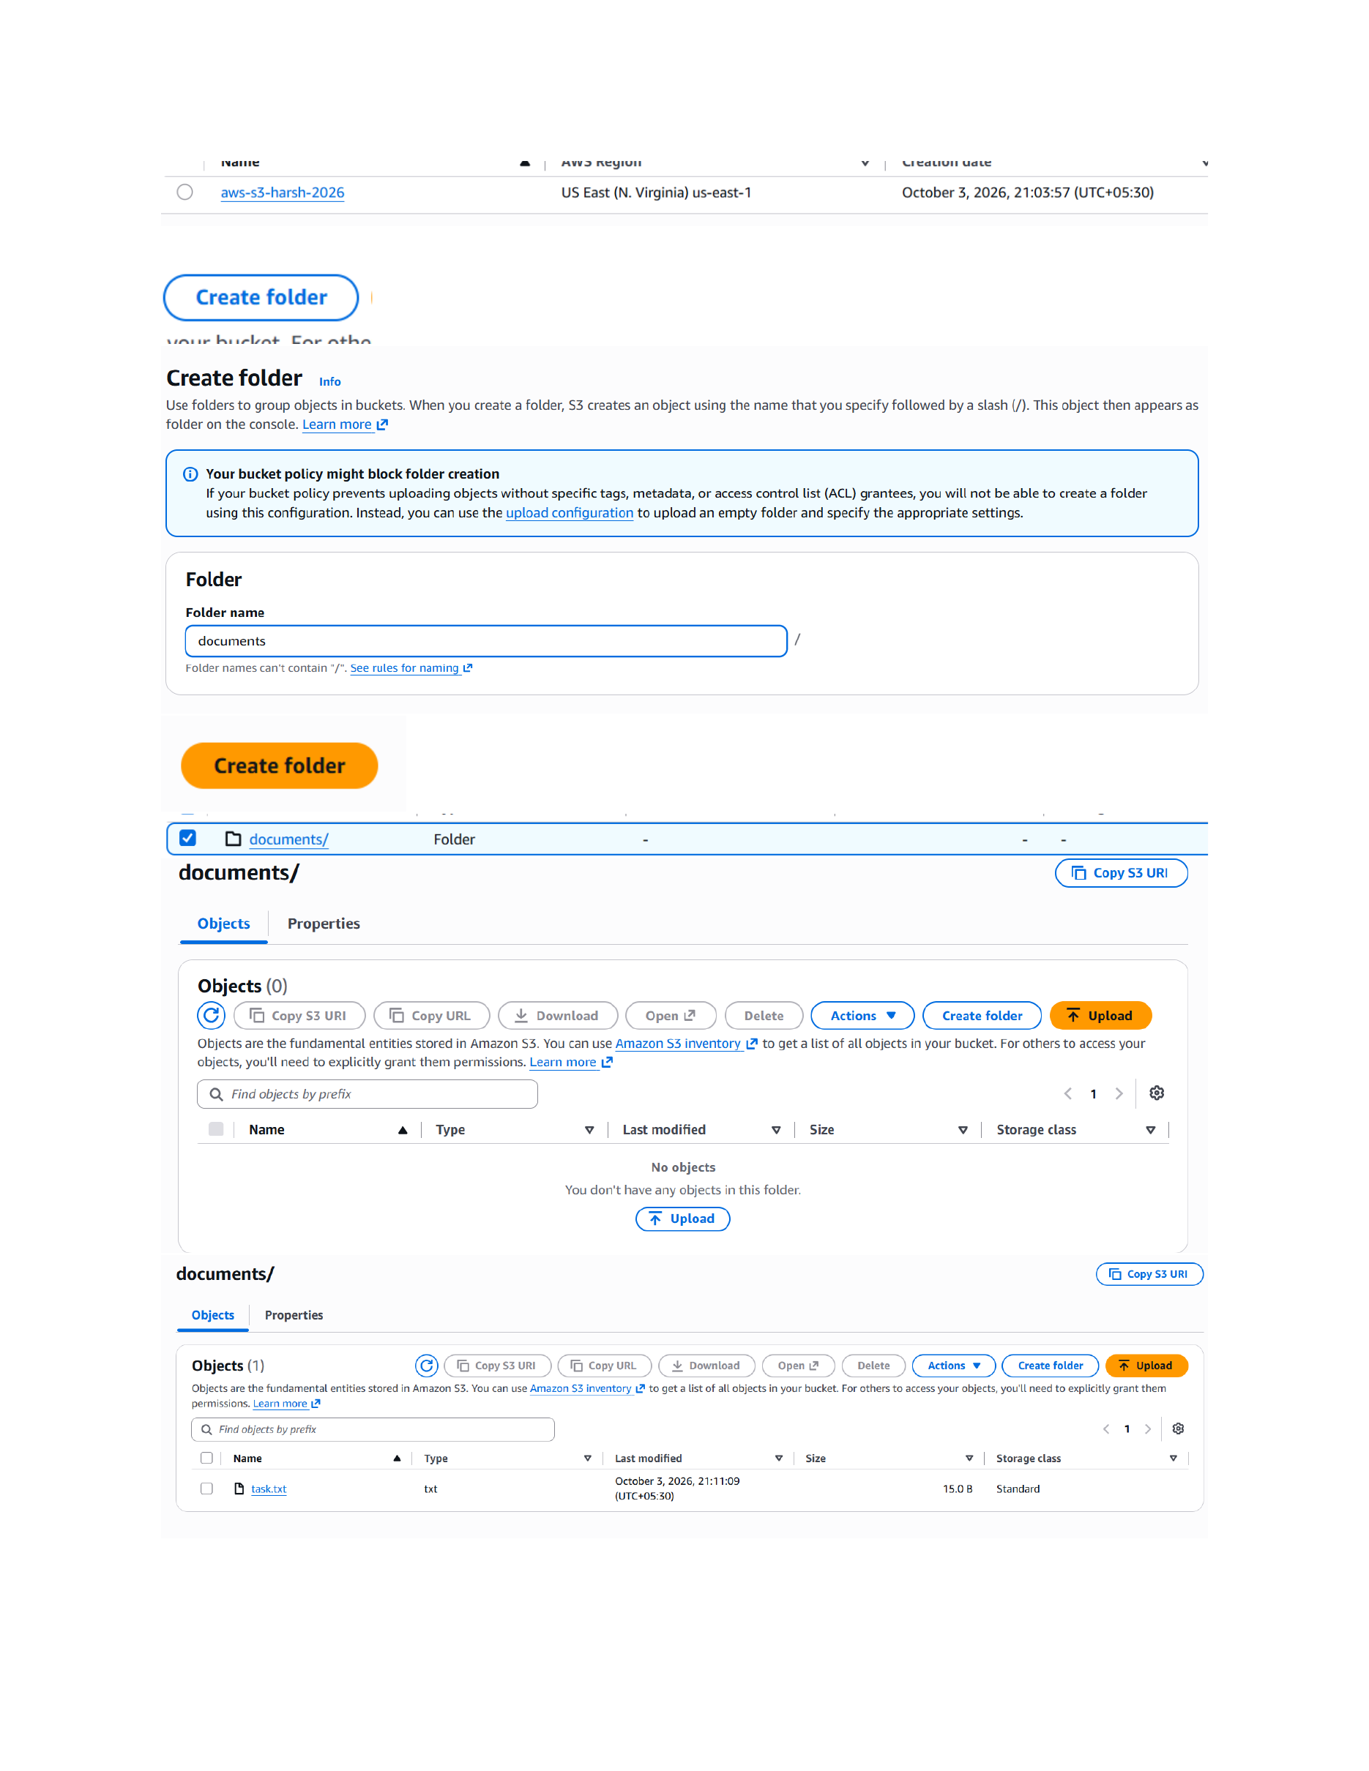
Actual action: A folder is created inside the S3 bucket, and the bucket view shows the resulting folder/object structure.

Page 5 — Configure Bucket Permissions
Topic: Bucket policy and permissions
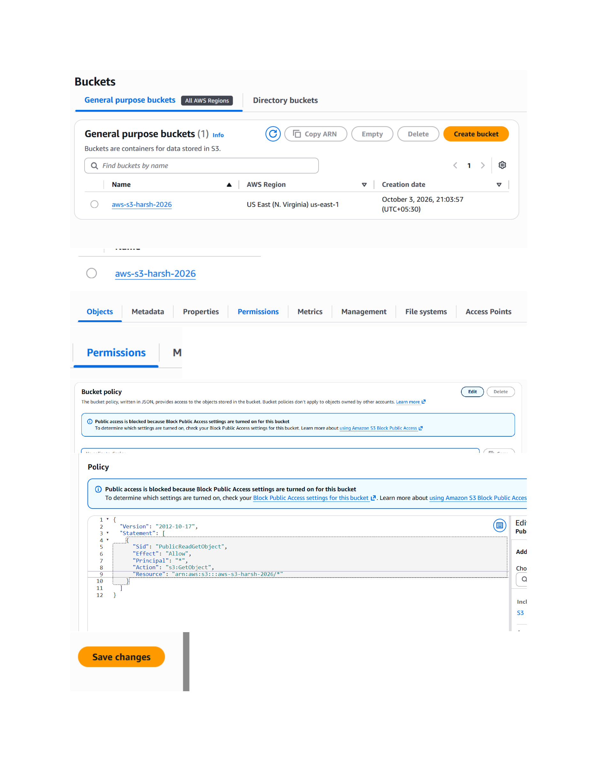
Actual action: The bucket Permissions area is opened and the bucket policy editor is used to enter the shown JSON policy before saving the changes.

Page 6 — Edit the Bucket Policy
Topic: Policy configuration for S3 access
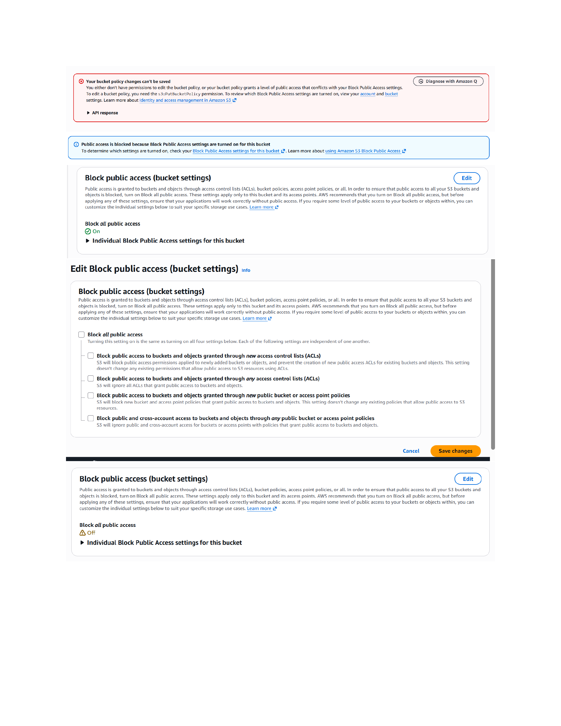
Actual action: The bucket policy configuration is reviewed/edited in the Permissions section, including the policy JSON and the Save changes action.

Page 7 — Prepare the Static Website File
Topic: index.html content for the S3 website
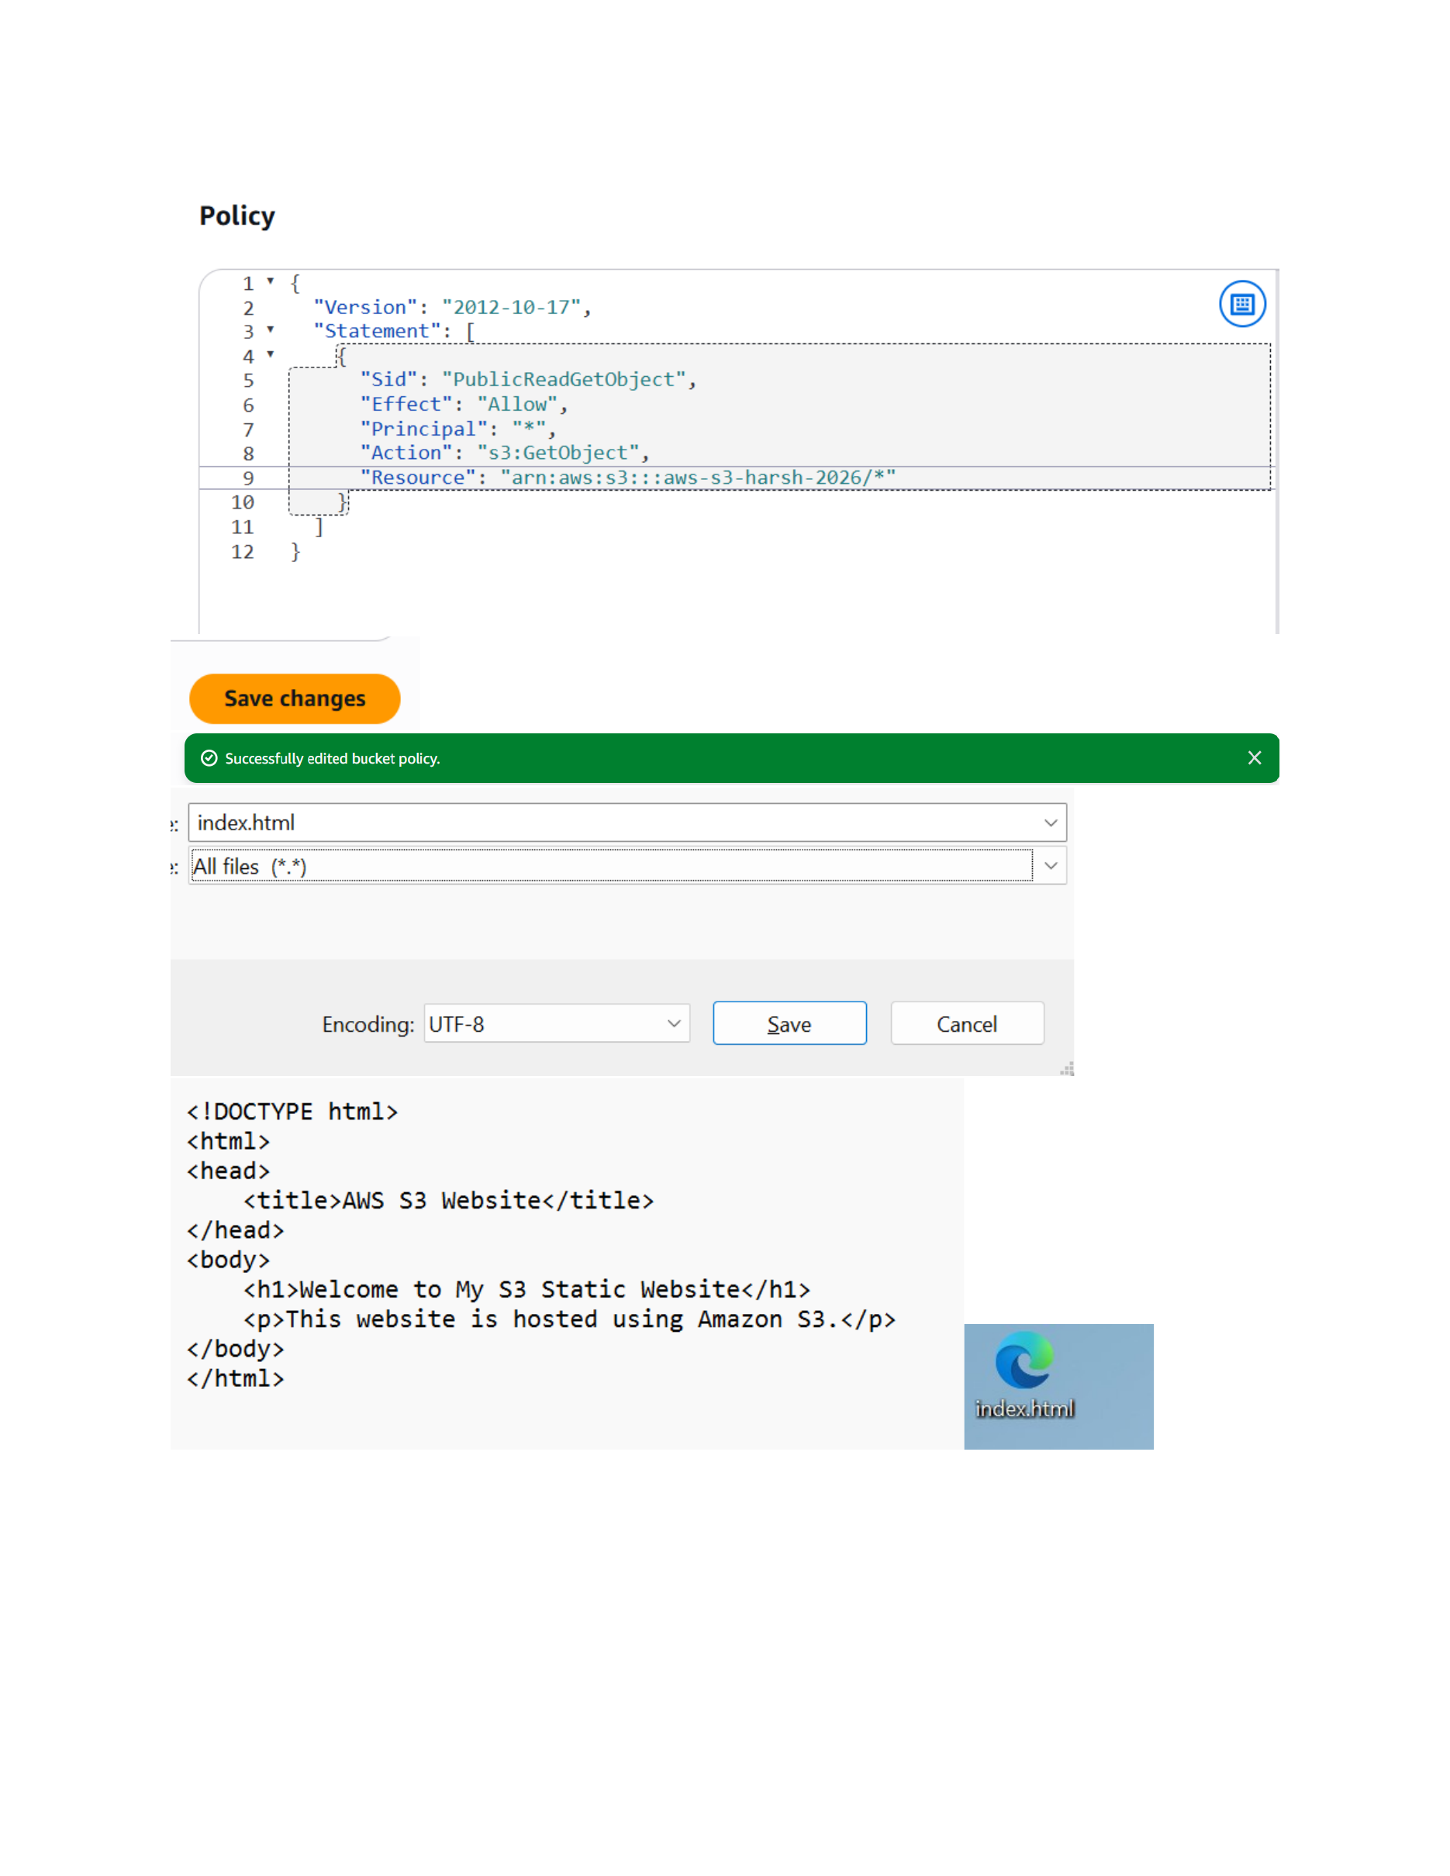
Actual action: The shown HTML content is created for the static website, including the page title and the visible welcome text, and the file is prepared for upload.

Page 8 — Enable Static Website Hosting
Topic: S3 static website hosting configuration
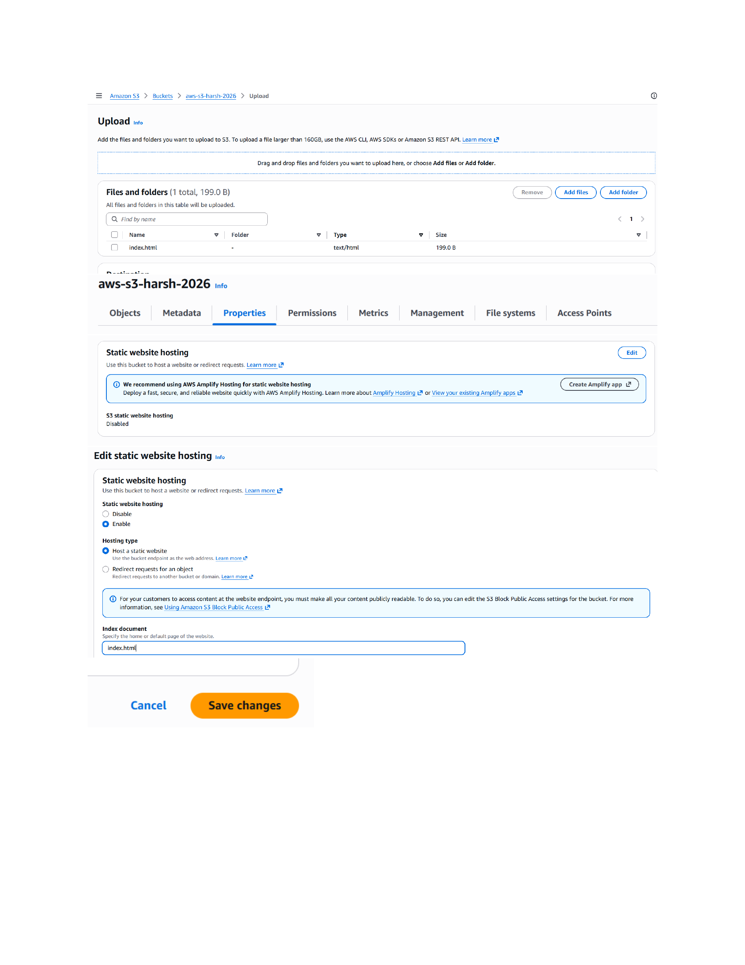
Actual action: Static website hosting is enabled in the bucket Properties area and the website configuration is saved with the shown index document settings.

Page 9 — Open the S3 Website Endpoint
Topic: Static website endpoint verification
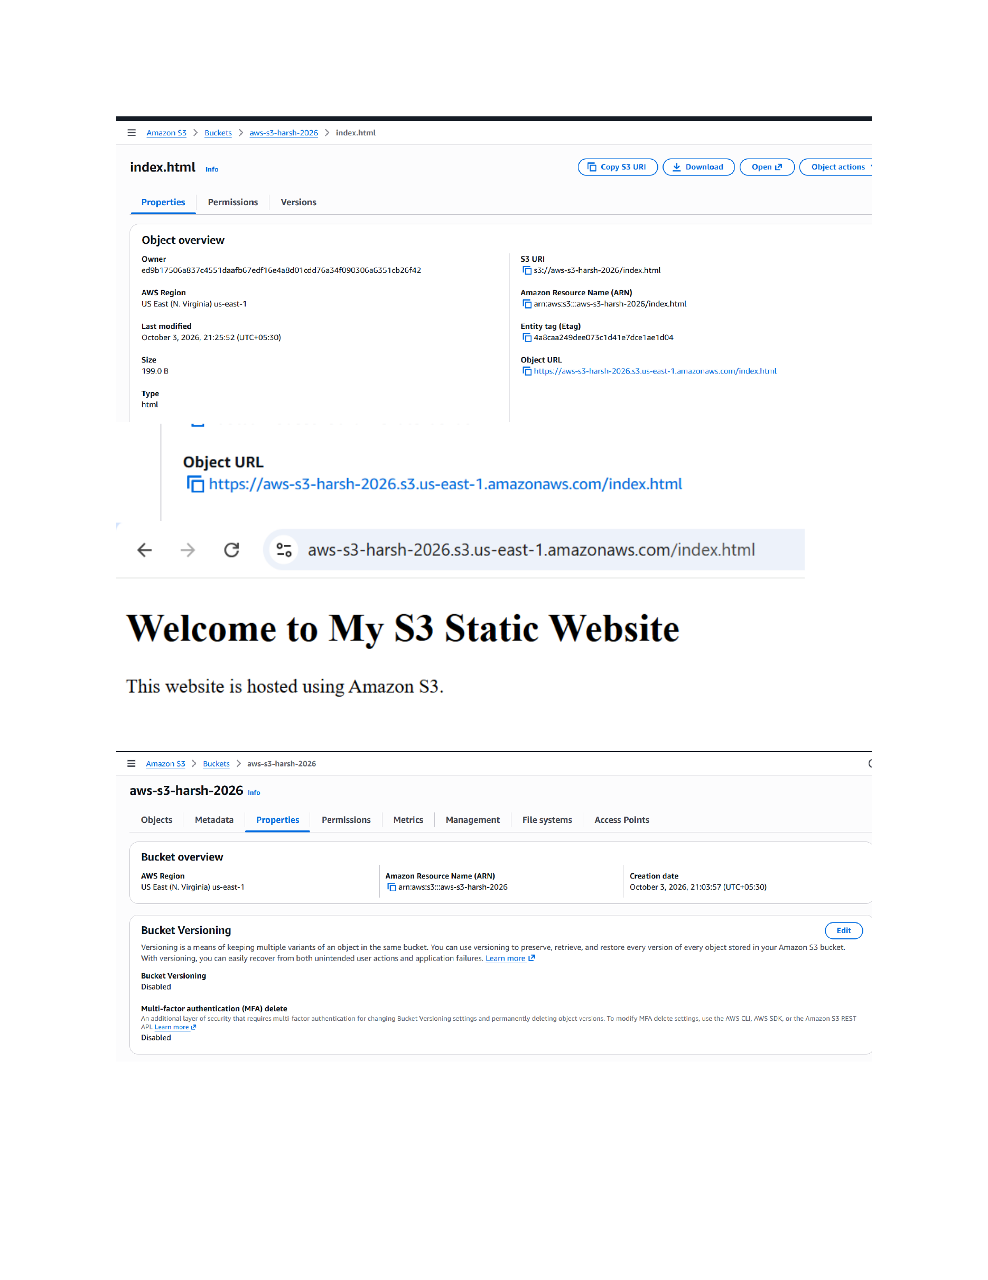
Actual action: The S3 static website endpoint is opened in a browser and the rendered 'Welcome to My S3 Static Website' page is displayed.

Page 10 — Update the Website Content
Topic: Editing and uploading a new index.html version
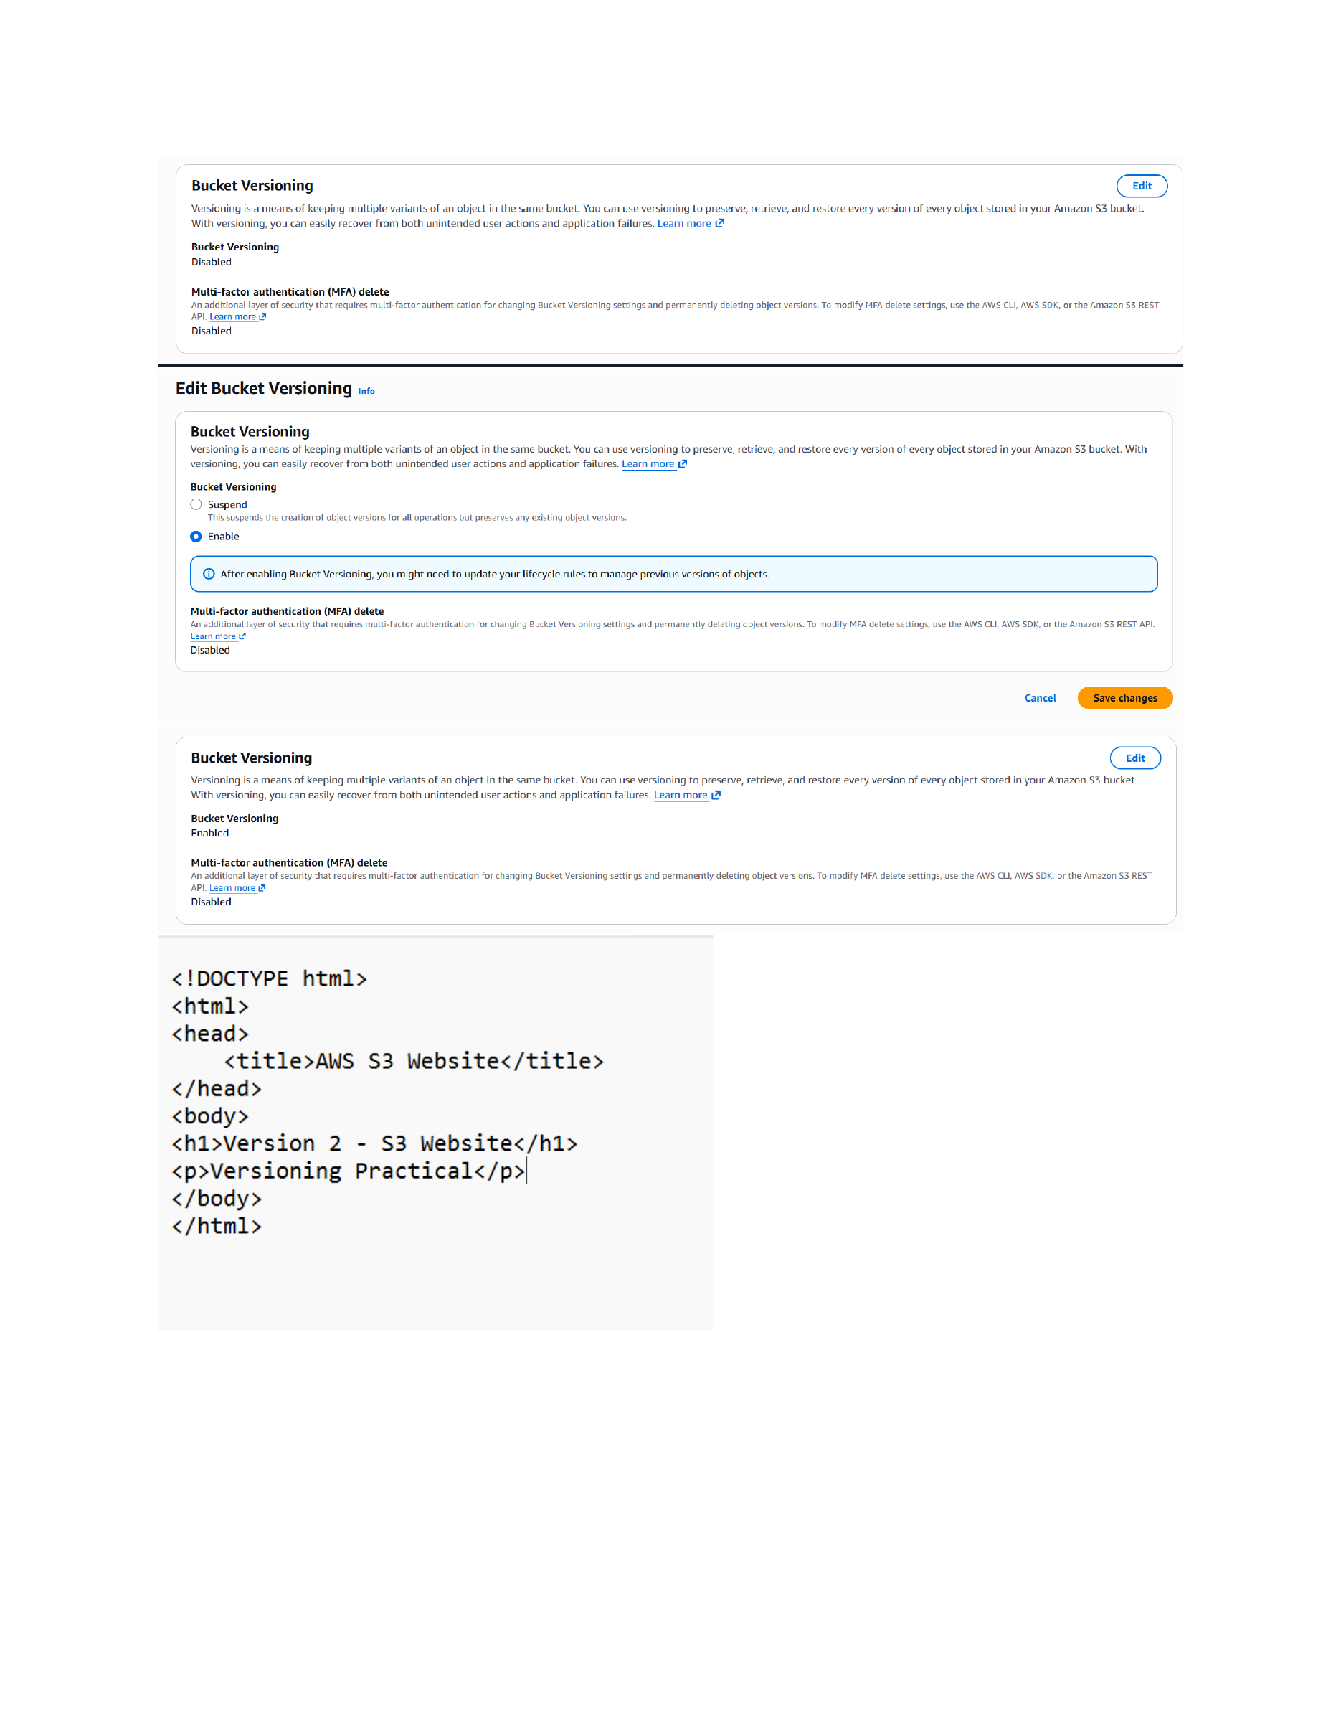
Actual action: A new version of the website HTML is prepared and uploaded through the S3 upload workflow, with the updated HTML content shown.

Page 11 — Verify Versioned Website Objects
Topic: Object versions and website content
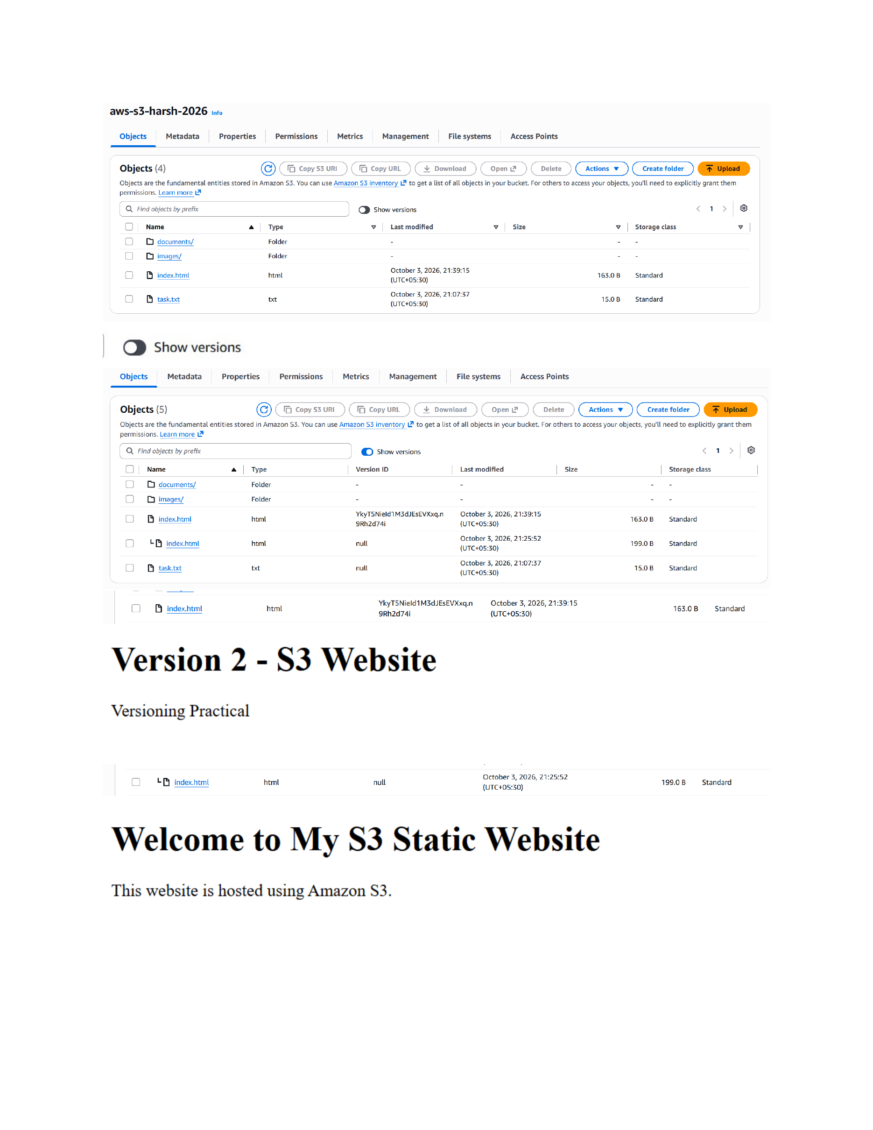
Actual action: The bucket's object/version view is checked and the updated website content is displayed, including the Version 2 page heading and welcome message.

Page 12 — Configure S3 Lifecycle Rules
Topic: Lifecycle rule creation and scope
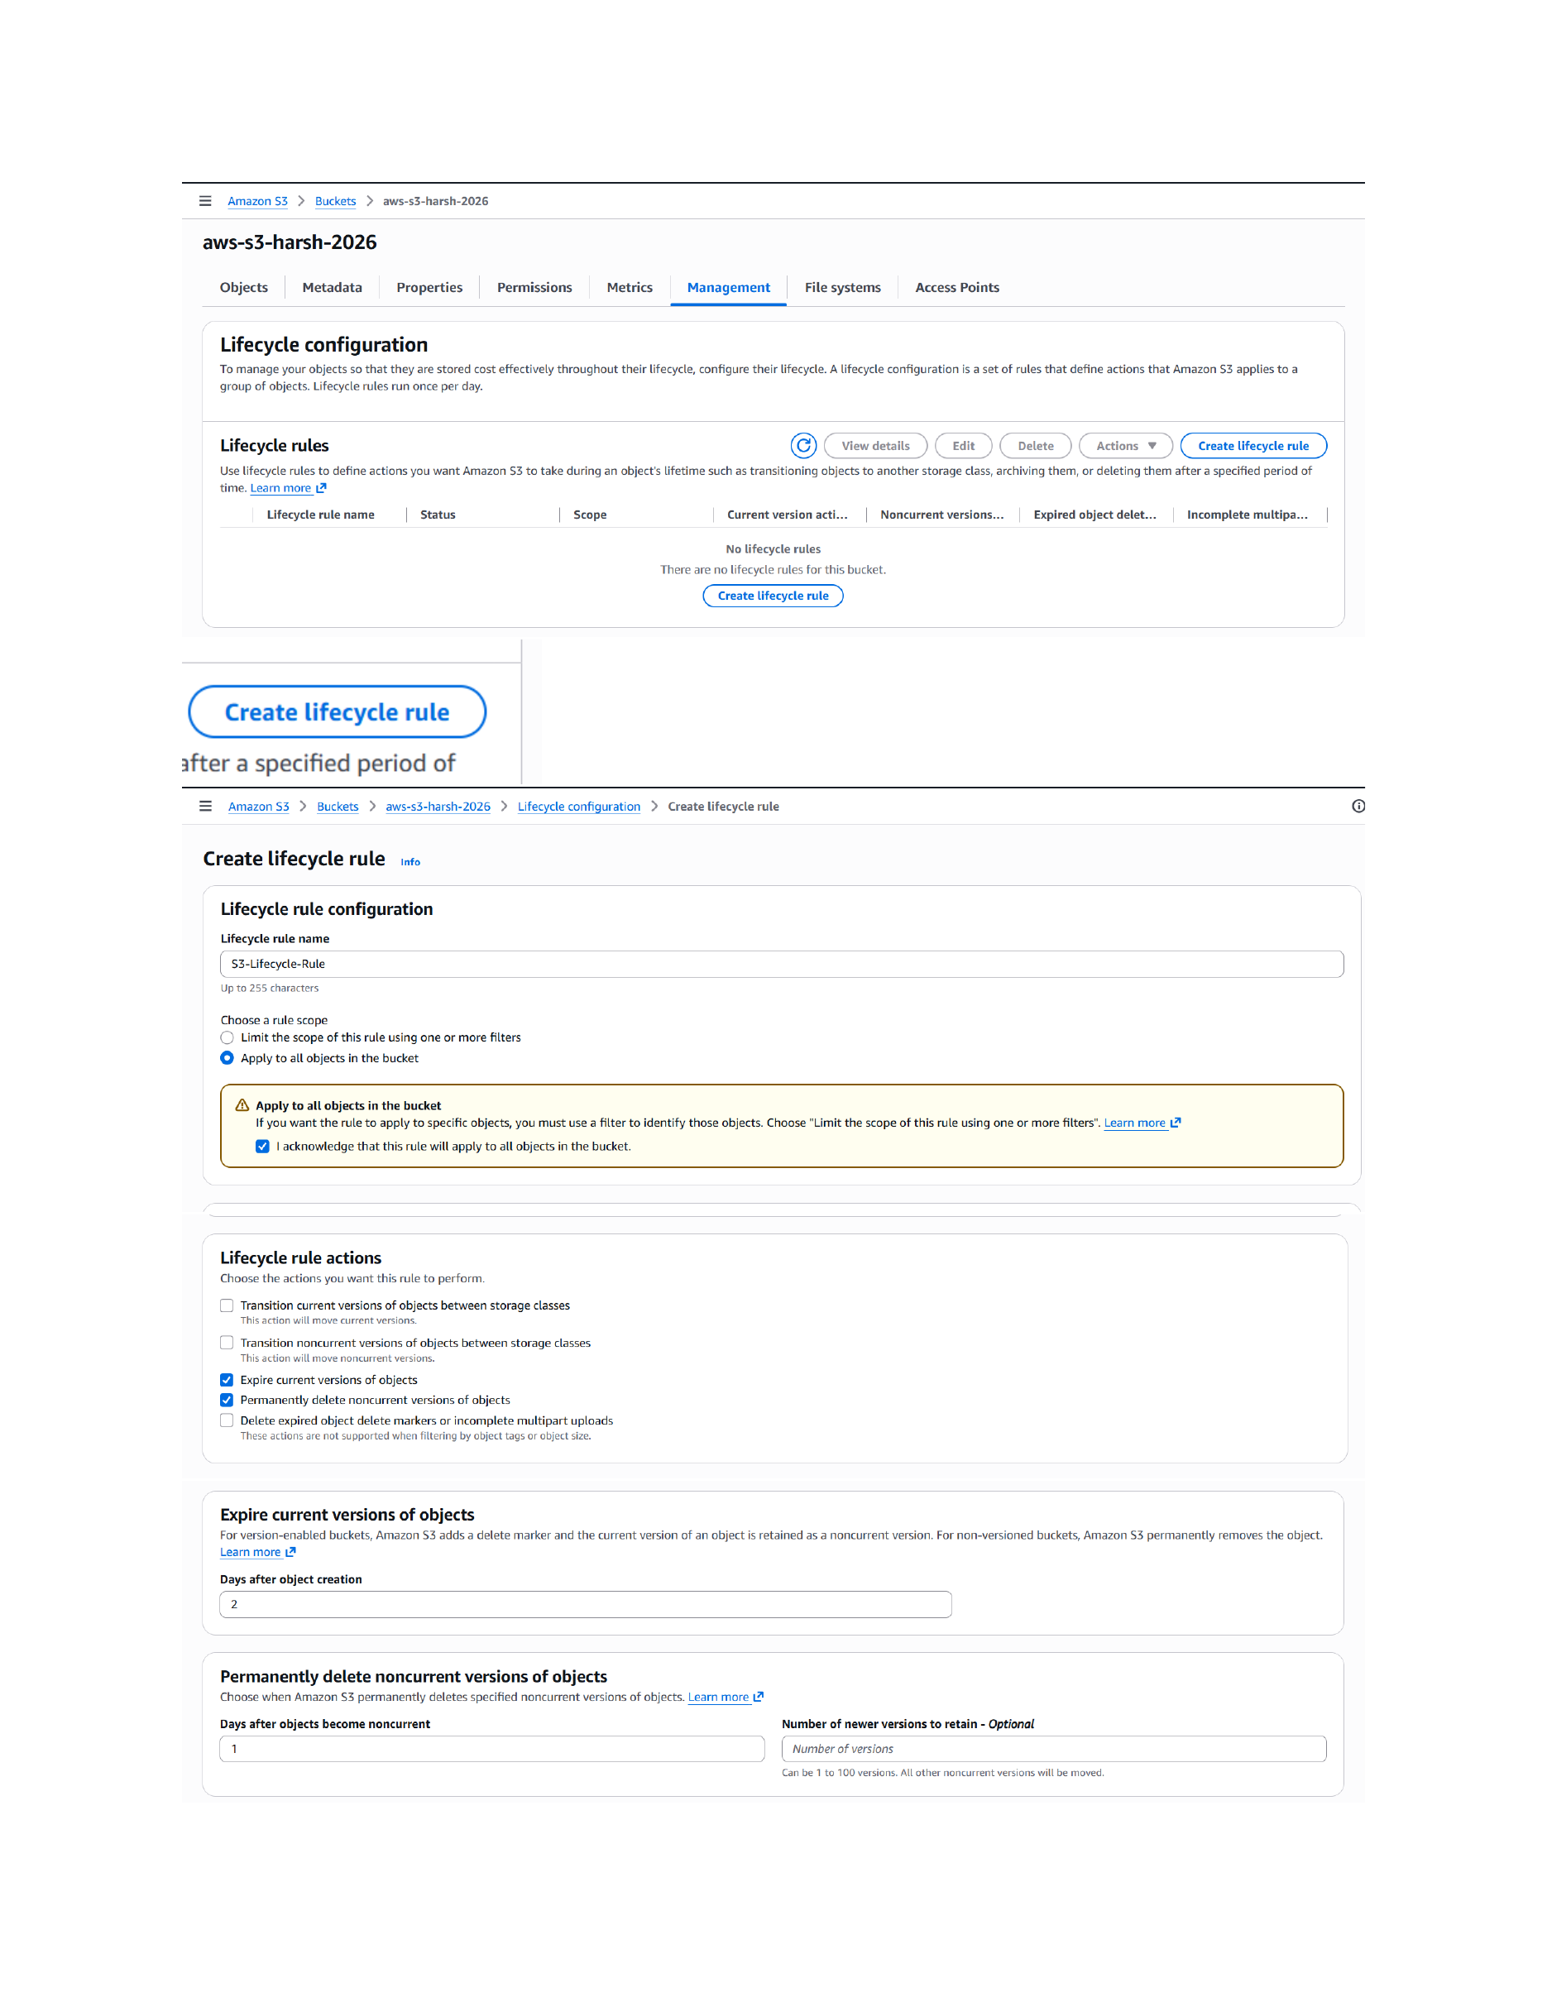
Actual action: A lifecycle rule is created/configured in the S3 Management area, with the shown rule scope and lifecycle settings.

Page 13 — Review Lifecycle Actions
Topic: Lifecycle transition/expiration configuration
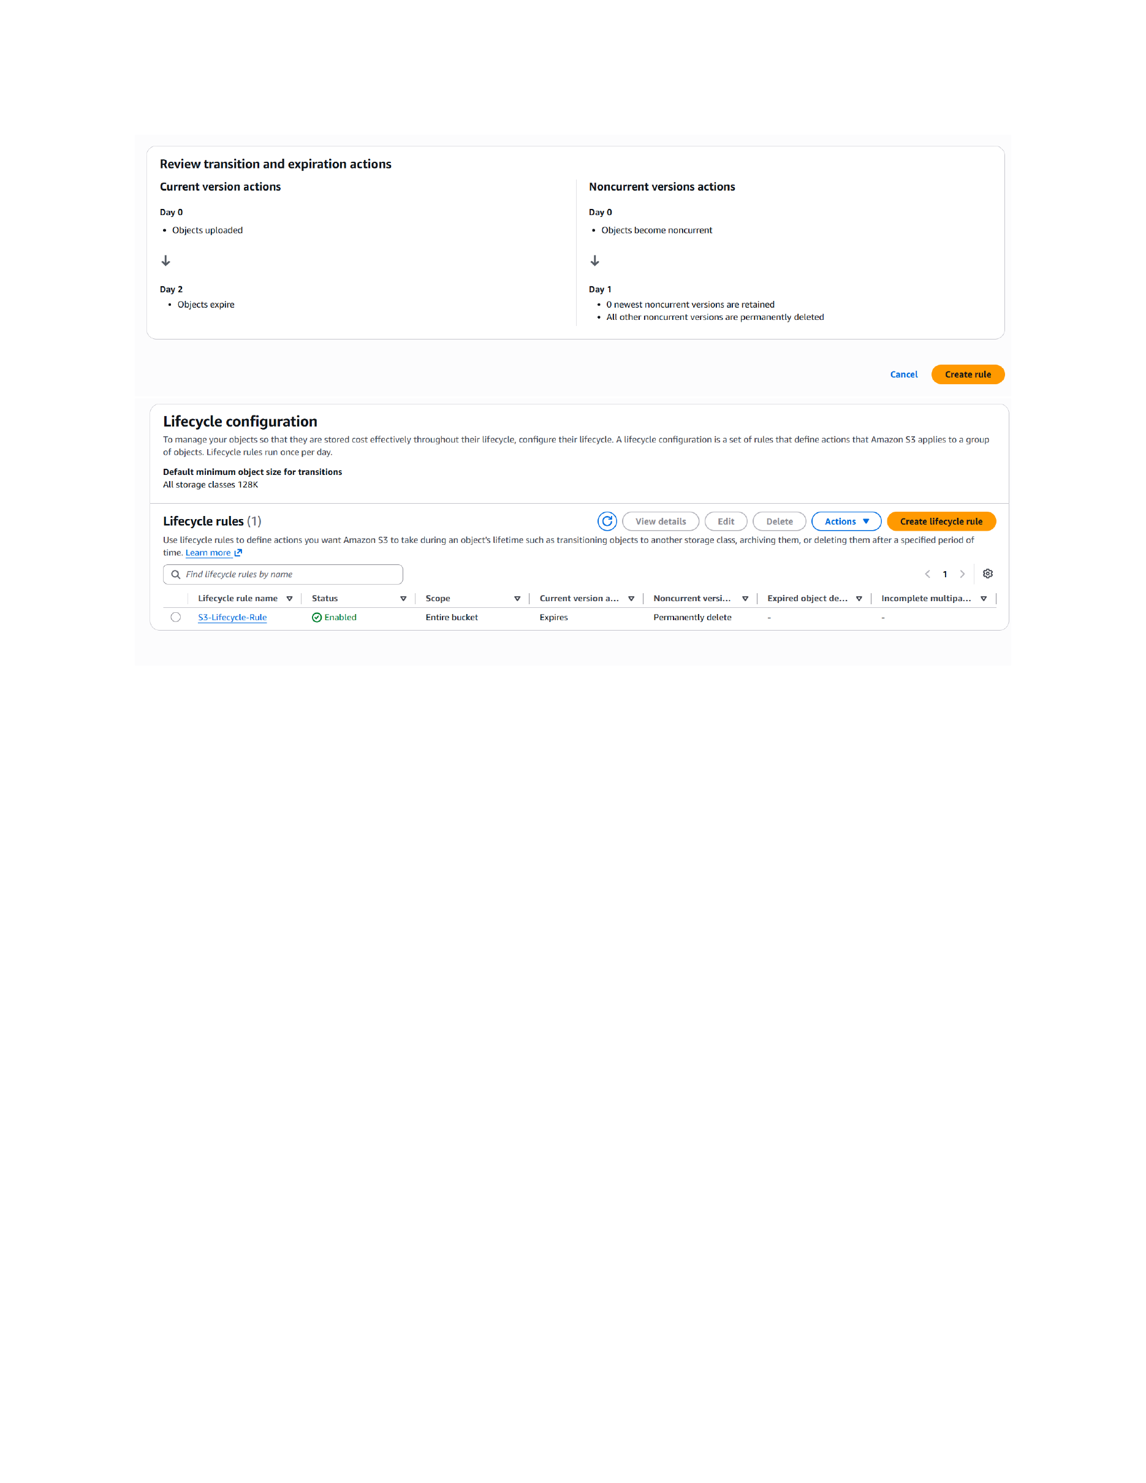
Actual action: The lifecycle rule's transition and expiration actions are reviewed/configured, and the rule is ready to be saved.

